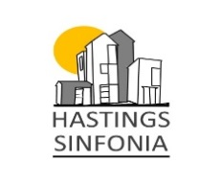

**Friends of Hastings Sinfonia**

By joining the **“Friends of Hastings Sinfonia”** you will be able to support the long-term development of the orchestra by enabling us to continue to perform at least three concerts a year with a varied programme, professional soloists, guest musicians and at different venues.

As a local Community Orchestra, we also try to encourage and inspire young players to become the next generation of classical performers by inviting them to play alongside us.

Your annual membership will run from **1st January to 31st December** and it will entitle you to:

* Reserved seating in the front rows of our St John’s Church concerts (ticket price not included).
* A complimentary drink during the intermission – please collect/bring your membership card on arrival.
* An opportunity to come along and meet the orchestra at one of the rehearsals.
* Your name in our Friends listing on concert programmes (optional)
* An opportunity to make a request for a piece of music to be played in our concerts

Hastings Sinfonia gratefully acknowledges the support of our “Friends” and we look forward to meeting you at our concerts.

You will receive a contact email/telephone call on joining to welcome you, and prior to our concerts to assist with preparation of your seats, refreshments etc.

**Types of Membership:**

Single Membership Minimum :- £25/year 🞏

Couple Membership Minimum :- £40/year 🞏

Please email the co-ordinator directly if you wish to become a Business Sponsor or are considering leaving a Legacy.

Cash payments accepted on concert nights

BACS Payment to Metro Bank **Hastings Sinfonia,**

**Sort code: 23-05-80 Account no: 56522964**

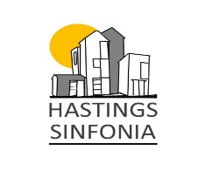

**Please complete the form below and send/scan it (or photograph) to:-**

The Co-ordinator, Friends of Hastings Sinfonia:- [hastingssinfoniafriends@gmail.com](mailto:hastingssinfoniafriends@gmail.com)

Contact:- 07846904247

NAME/S:- ……………………………………………………………………………………………………………………………………….….

Address:- ……………………………………………………………………………………………………………………………………………

……………………………………………………………………………………………………………………………………………………………

……………………………………………………………………………………………………………………………………………………………

Email:- …………………………………………………………………………………………………

Contact number:- ………………………………………………………………………………………………..

Connection to the orchestra, if any? ....................................................................................................

Preferred method of contact? email/phone

Preferred method of payment BACS / CASH

* (Please use the Reference “FR-your initials-2025 if paying with BACS)

Single Membership Minimum :- £25/year 🞏

Couple Membership Minimum :- £40/year 🞏

* I am a new Friend 🞏
* I wish to renew my yearly Friends’ membership 🞏
* Would you like your **name** to appear in the concert programme Yes/No
* My preferred intermission drink is: – Red wine/white wine/soft drink/other

(please state both drinks if two are required) …………………………………………………..

* BACS Payment to Hastings Sinfonia, Metro Bank, Sort code :23-05-80 Account no: 56522964